**Project Details**

|  |  |
| --- | --- |
| Project number | *Project 1* |
| Project title | *Mega Store* |
| Corresponding TA\LA | *1* |
| Deliverable | *Phase 4* |

**Team Details**

**Team 8**

|  |  |  |
| --- | --- | --- |
| **Student ID** | **Student name** | **Lab Group** |
| 20200403 | Loay Mohamed Hussien | S3-S4 |
| 20200490 | Mahmoud Ahmed Abdo | S1-S2 |
| 20200687 | Ibrahim Rashid Ibrahim | S1-S2 |
| 20200479 | Mohammed Nasser Abdel-Samea | S1-S2 |
| 20200125 | Ganna Allah Khaled Fouad | S3-S4 |
| 20201185 | Nadeen Medhat Assem Abdel-Latif | S3-S4 |
| 20200143 | Habiba Adel Lotfy ELbatrawy | S3-S4 |

**1 A) CRC Card: Use case diagram (Add product), entity classes (Manager – Product)**

**Partial class diagram:**

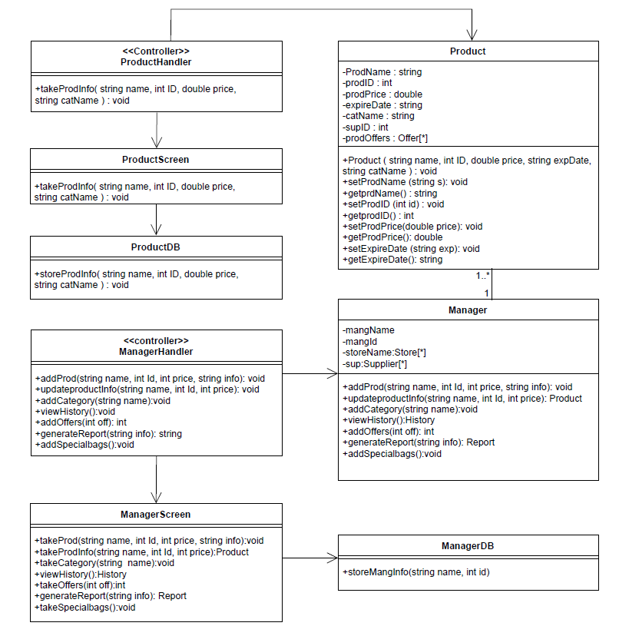

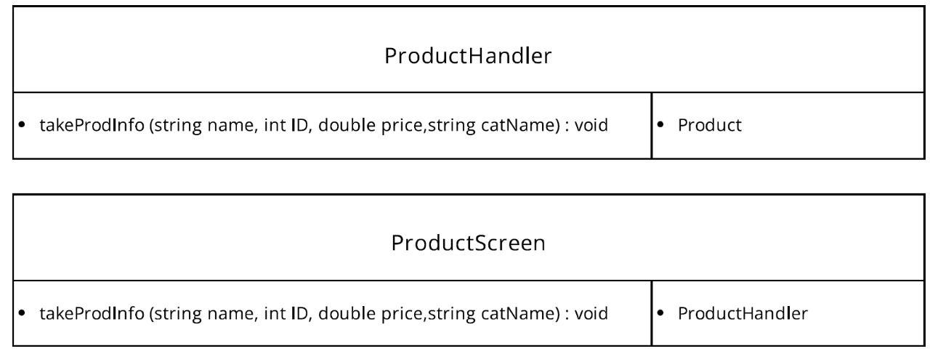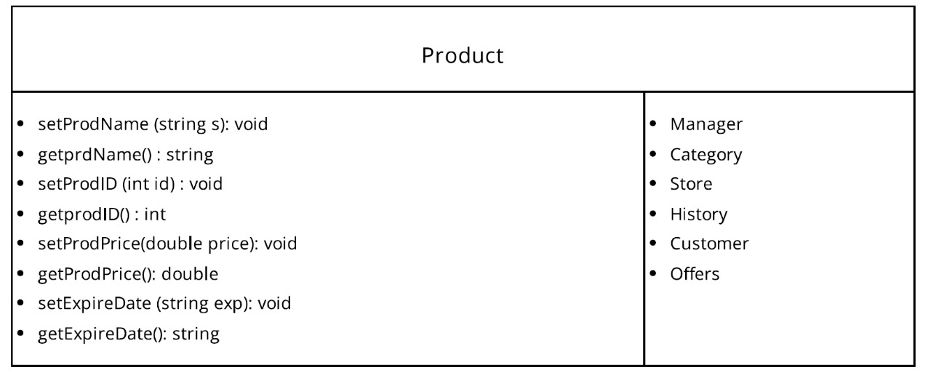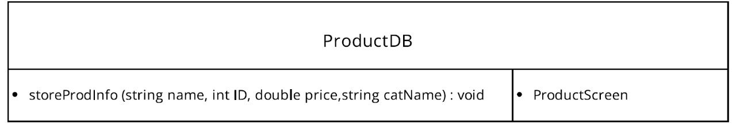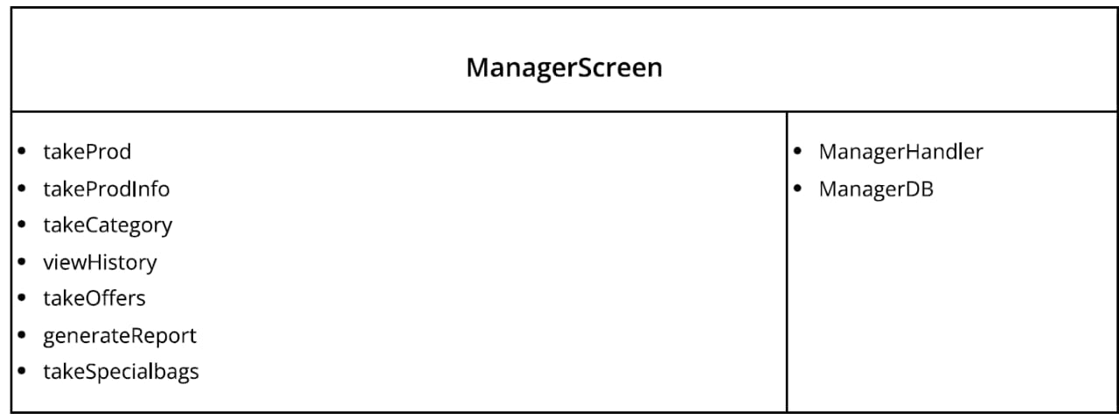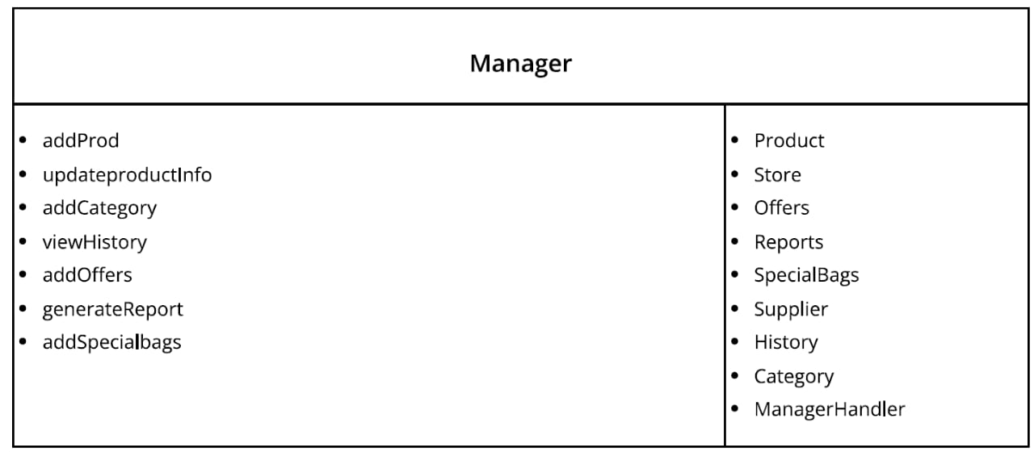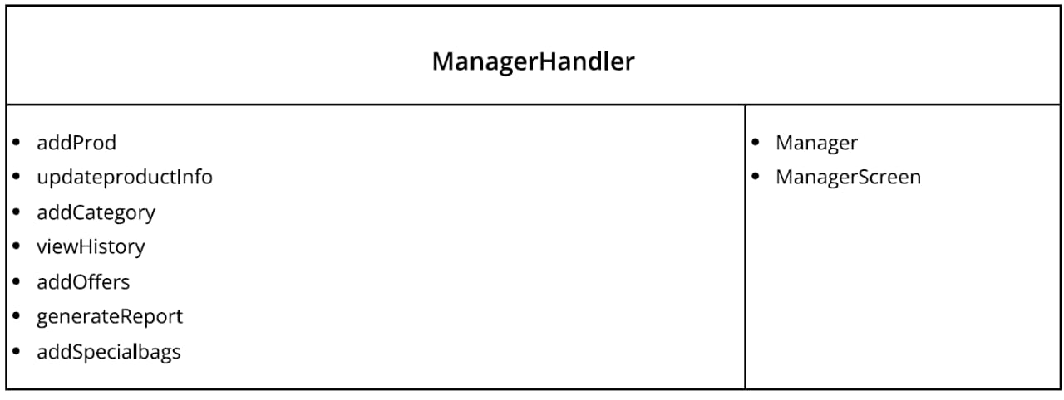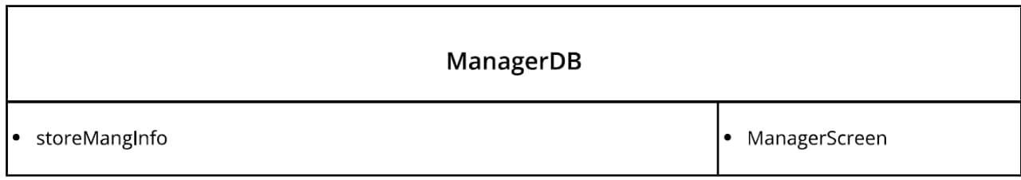

**1 B) Communication diagram: Use case diagram (Add offers), entity classes (Manager – Product – offers)**

**Partial class diagram:**

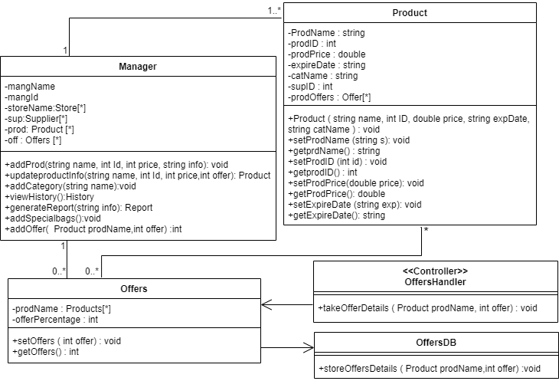

**communication diagram:**

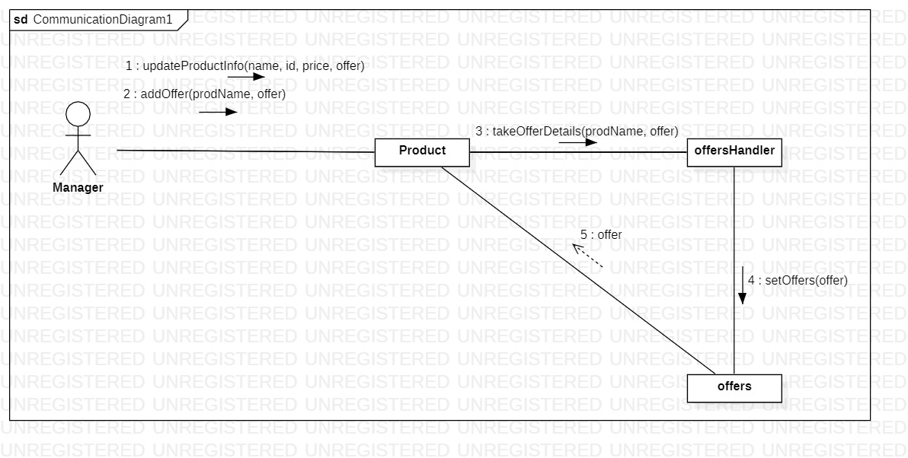

**2) Sequence diagram: Use case diagram (Add to cart), entity classes (Product – Cart – Customer)**

**Partial class diagram:**

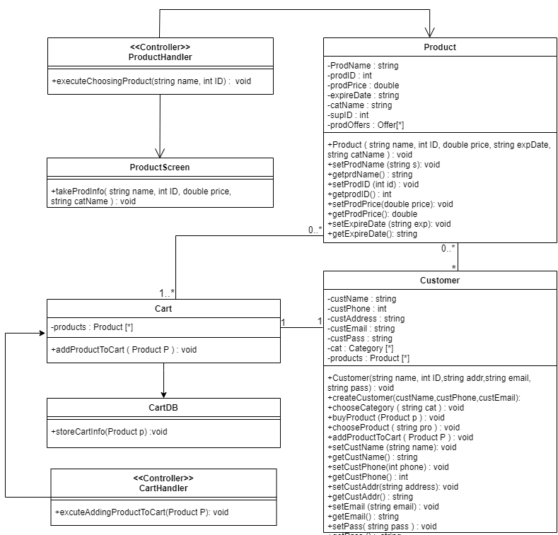

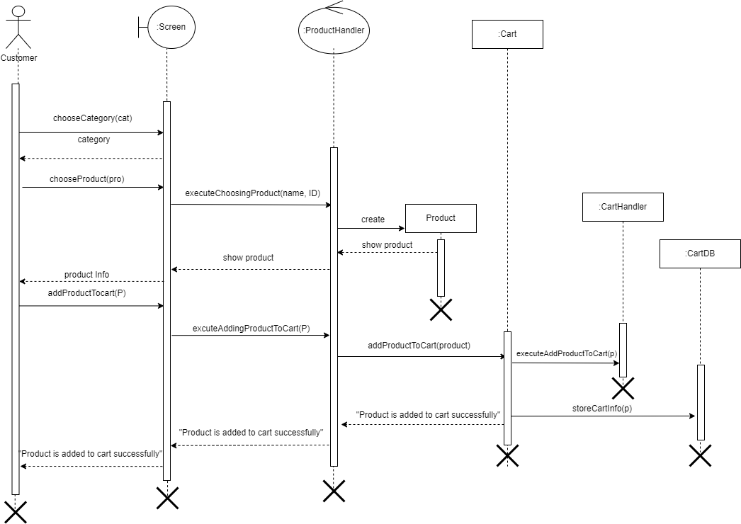**Sequence diagram:**

**2) Sequence diagram: Use case diagram (Checkout), entity classes (Product – Payment – Customer)**

**Partial class diagram:**

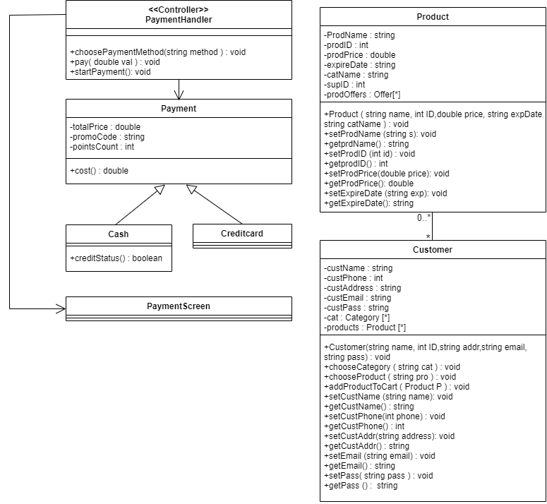

**Sequence diagram:**

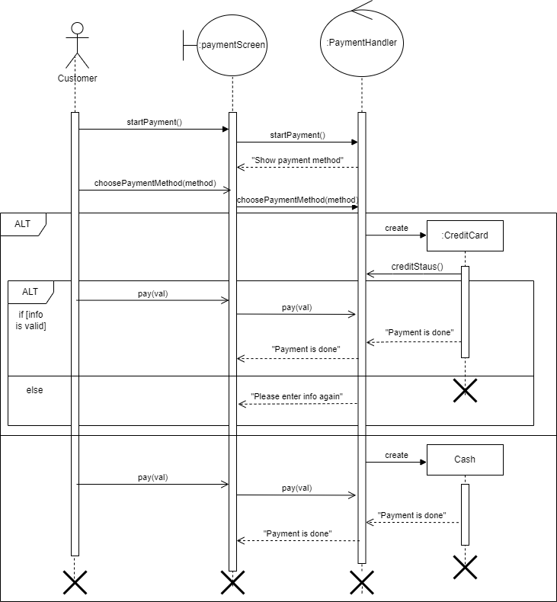

**3) Generate and draw final-cut class diagram output from 1.a, 1.b, and 2 [Fully-defined attributes and methods, navigation, multiplicity].**

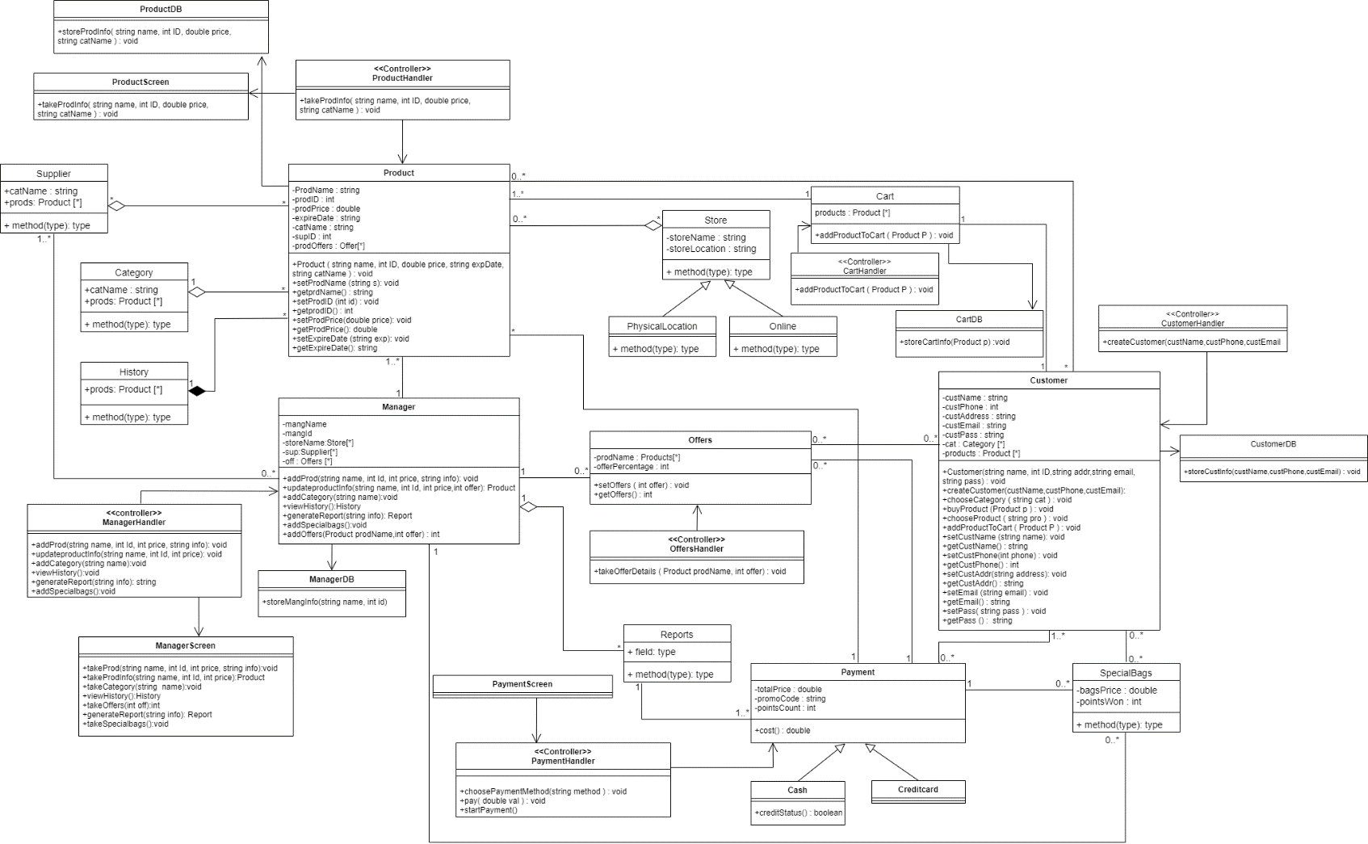

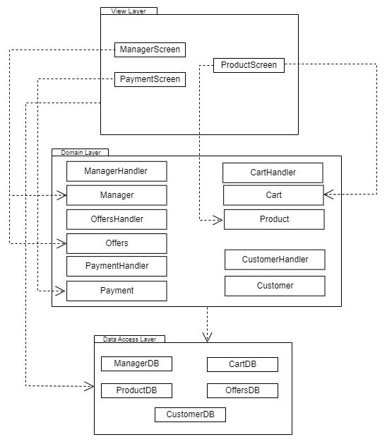**4) Generate and draw package diagram from the resulted detailed class diagram in 3.**